43.61: The activity 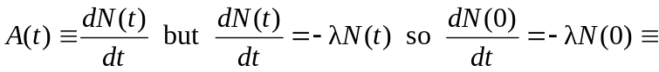
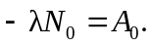 Taking the derivative of 